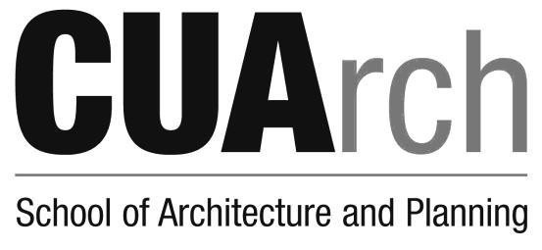

PROGRAM CHANGE FORM
This form is to be completed by students currently in the School of Architecture and Planning who are changing their degree program to another program within The School of Architecture and Planning.
*Students entering or leaving the joint degree program should complete the Request for Program Change - Transfer Between Schools Form available on the Enrollment Services Website

Current Program New Program

B.S. Arch
B.A.A.S
B.S.C.R.S.
B.S.E.S
B.S. Arch
B.A.A.S
B.S.C.R.S.
B.S.E.S

Effective Semester/Year of Change: ________________

Printed Name of Requesting Student ID Signature Date

Printed Name of Associate Dean |  | Signature | Date

The Catholic University of America School of Architecture & Planning

